***Benevolent Lodge #3***

***200th Celebration***

***of***

***Brother Marquis de Lafayette’s Historical Visit***

**Gilbert du Motier, Marquis de Lafayette**

As a rEVOLUTIONARY wAR Soldier

Lafayette offered to serve in the Continental Army without pay and was commissioned by

Congress as a major general on July 31st, 1777. Within days, the Marquis met General

George Washington, commander in chief of the Continental Army, and the two formed an

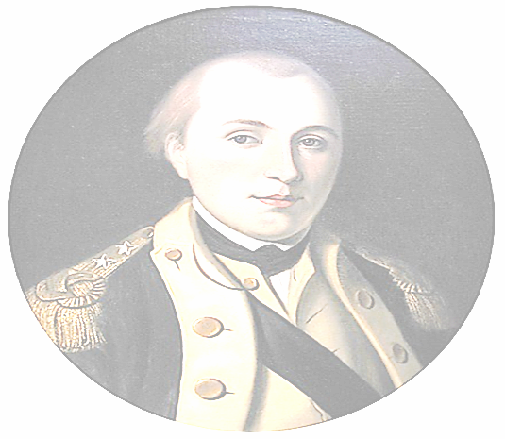instant bond.

The American Revolution

The commanding general made the Marquis a member of his staff on which he served for six weeks. He got his first taste of combat at the Battle of the Brandywine, near Philadelphia, on September 11th, 1777. Lafayette was shot in the leg but rallied the American troops for a more orderly pullback before seeking treatment for his wound. Washington recognized and cited him

for his valor, choosing to give the Marquis command of his own division.

His role in the revolution only grew from this moment on. He spent the legendary winter at

Valley Forge camped with Washington, coming to respect his leadership more while the

two grew closer. Lafayette played a critical role in the Battles of Barren Hill, Monmouth,

and Rhode Island. Lafayette returned to France in June 1778 to broker more support for the

United States. Working alongside Benjamin Franklin and John Adams, the three persuaded

Louis XVI to provide additional troops and supplies to aid the colonists. Lafayette returned

to America in April 1780, having secured 6,000 French infantry under the command of the

Comte de Rochambeau and six ships of the line.

One of his most significant accomplishments of the war came in the summer of 1781 when Washington dispatched him to stop British raids along the James River in Virginia. He was

given command of an army and began hit-and-run operations against forces under Benedict

Arnold. Lafayette’s force chased British commander Lord Charles Cornwallis across Virginia, forcing him into a corner at Yorktown. French and American forces laid siege to Yorktown,

forcing the surrender of the British and securing Lafayette’s status as the “Hero of Two

Worlds.” For his part in the revolution, the Marquis became an honorary citizen of several

states on a visit to the United States.

As A Free Mason

On the topic of Freemasonry, it has been disputed for two centuries where Lafayette became

a Mason. There are no definitive records showing exactly when and where Lafayette was

initiated. Lafayette was a hero of both the American Revolutionary War and later two

French revolutions. Freemasons from both countries are anxious to claim him as their own.

French Masonic scholars believe he was made a Mason in France prior to coming to America

and enlisting in the Continental army. However, the most widely accepted and best supported belief is that Lafayette was made a Mason after coming to America, most likely after meeting George Washington. This version is supported by Lafayette’s own writings. American Masonic scholars place the time of the initiation during the winter of 1777-78 when Washington’s army

was wintering over at Valley Forge. It is believed that General George Washington himself may have acted as Master of the Lodge during Lafayette’s initiation ceremony.  
  
Dr. George W. Chaytor was a noted Masonic scholar and past master. Addressing the Lafayette Lodge No. 14 in Wilmington, Delaware, on January 18, 1875, he made the following statement

on the subject of Lafayette’s admission into the Masonic order:  
  
He [Lafayette] was not a Mason when he landed in America, nor was he a Mason at the Battle

of Brandywine. The Army under Washington, in December, 1777, retired to Valley Forge,

where they wintered. Connected with the Army was a Lodge. It was at Valley Forge that he

was made a Mason. On this point there should be no second opinion—for surely Lafayette

knew best where he was made a Mason.

Lafayette’s own remarks do support the fact he was made a Mason in America, after having

met General George Washington. Lafayette said, “After I was made a Mason, General

Washington seemed to have received a new light—I never had, from that moment, any cause

to doubt his entire confidence.

Reportedly, Lafayette, himself, said that he was first raised in France before coming to America.

He was made a Mason in either Loge La Candeur in Paris, or Loge Contrat Social of Paris.

After coming to America it was also said that he was raised at a military lodge in Morristown,

N.J., or at Valley Forge in 1777.

Lafayette received more Masonic honors than any other Freemason, before or since and has

more than 75 Masonic Bodies named after him. He also became a Royal Arch Mason, joining Jerusalem Chapter No. 8 in New York City on September 12, 1824. He then joined the Knights Templar in Morton Commandery No. 4 and in Columbian Commandery No. 1, both of New

York City. In the Scottish Rite, he received the degrees in the Cerneau Supreme Council of

NY, and was made a 33rd degree Mason.

Lafayette’s Visit to Benevolent Lodge #9

and Fraternal Lodge #20

(Report from the *Georgia* *Journal, Milledgeville, Ga.*)

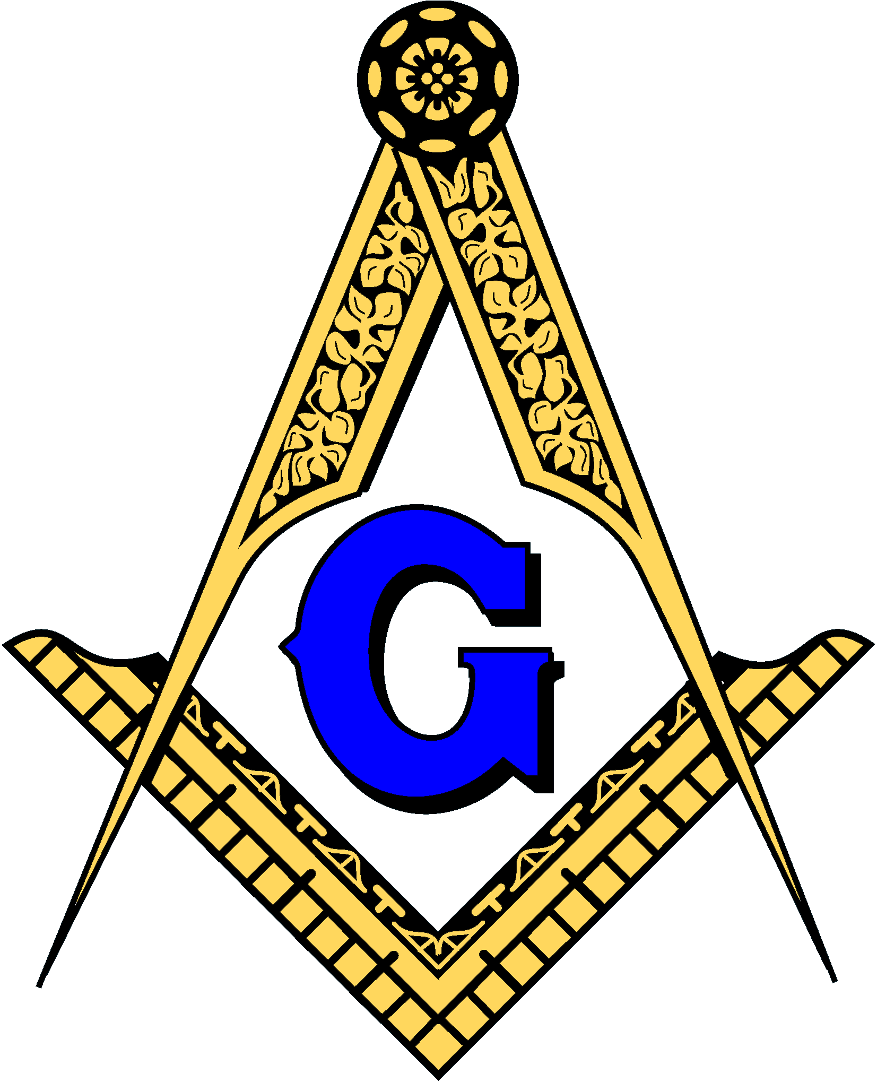

The Masonic Fraternity had made arrangements for his reception. A Committee consisting

of Messrs. Hansell, Calhoun, Davis, Ragland, and Rockwell, addressed him as follows:-

***General -*** In the name of the Fraternity of Free Masons in this place, duly assembled, we

their committee, have the pleasure to greet you as a Most Worthy Brother of our ancient

and honorable order. With extraordinary emotions, we now appear before one so eminently

distinguished for his virtues, philanthropy, and patriotism, both in America and Europe;

and know, that at the same time we are permitted to hail him as “Brother”! We in behalf

of the Brethren, solicit the favor of our distinguished and Worthy Brother Lafayette, that

he will honor our infant institution with a visit, this day, at such time as to him may be

convenient.

***To which the General replied*** –“I am most happy in having an opportunity of visiting

the Masonic Fraternity at this place; my stay being so short. I must avail myself of their

kind invitation between the hours of 10 and 11 o’clock this morning”, on my way to the

State-House.”

Accordingly at half past 10, he was conducted to the Masonic Hall, where a large number

of the Fraternity was collected. Mr. Rockwell, in their behalf, addressed him as follows.

Worthy Brother - The Lodges of this place, anxious to offer you their affectionate

greetings, as a member of their fraternity, could not forego the opportunity presented

by your brief sojourn among us, of soliciting the honor of your presence in their Hall,

for the purpose of paying a just but humble tribute to the distinguished public and private

virtues which adorn the character of our illustrious Brother.

If anything can add to the pleasurable emotions which now swell our bosoms, it is the

reflection that the great and good Lafayette enjoys the blessings of health.

As the compatriot of our beloved Washington; as the early defender of our country, in

our country’s greatest peril, we offer you, as Masons and Americans, a heart warm

welcome.

Brother – There are situations, in which human language becomes but a faint representative

of the feelings of the heart, I feel that this is such a situation. Unable as I am to command

language appropriate to my emotions, I can only ask your acceptance of the sincere

homage of the warm hearts that surround you, accompanied with an ardent prayer to the

Supreme Master of Heaven, for your prosperity, peace, and happiness.

***The General’s Reply;*** Right Worshipful, and Brethren of this Lodge,

At every one of my visits to my Brethren of the American Lodges, I am happy to have

to acknowledge their friendly welcome, their kind remembrances, and to join in their

wishes for the cause of freedom, and for their sentiments of equality and philanthropy to

which Masons are bound by their oath, as well as by their own feelings: in this instance

most gratifying to me. I beg you to accept my affectionate and fraternal thanks!

From the Masonic Hall he proceeded to the State House, attended by the military, the

Masonic Fraternity, with their insignia, the several committees, and the citizens in

procession, where he was received by the Corporation and addressed by the Inteadant,

Mr. P.F. Joillet.

After the American Revolution

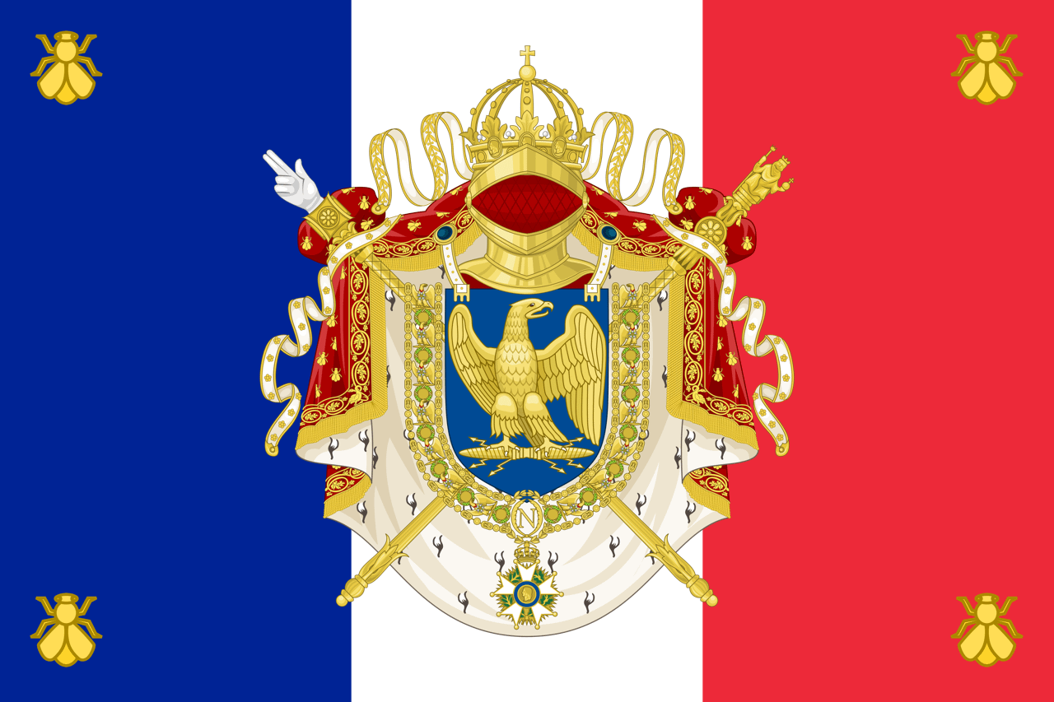

Lafayette returned to France and was appointed to the Assembly of Notables in 1787,

convened in response to the fiscal crisis. He was elected a member of the Estates General

of 1789, where representatives met from the three traditional orders of French society:

the clergy, the nobility, and the commoners. After the National Constituent Assembly

was formed, he helped to write the Declaration of the Rights of Man and of the Citizen with

Thomas Jefferson's assistance. This document was inspired by the United States Declaration

of Independence, which was authored primarily by Jefferson, and invoked natural law to

establish basic principles of the democratic nation-state. He also advocated the abolition of

slavery, in keeping with the philosophy of natural rights. After the storming of the Bastille,

he was appointed commander-in-chief of France's National Guard and tried to steer a middle

course through the years of revolution. In August 1792, radical factions ordered his arrest,

and he fled to the Austrian Netherlands. He was captured by Austrian troops and spent more

than five years in prison.

Lafayette returned to France after Napoleon Bonaparte secured his release in 1797, though

he refused to participate in Napoleon's government. After the Bourbon Restoration of 1814,

he became a liberal member of the Chamber of Deputies, a position which he held for most

of the remainder of his life. In 1824, President James Monroe invited him to the United States

as the nation's guest, where he visited all 24 states in the union and met a rapturous reception. On December10, 1824 the Marquis became the first foreign citizen to address the U.S. House of Representatives. During France's July Revolution of 1830, he declined an offer to become the French dictator. Instead, he supported Louis-Philippe as king, but turned against him when the monarch became autocratic.

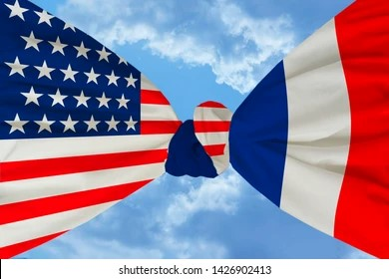

The Passing of the American Patriot and Hero

Brother Lafayette contracted pneumonia and died on 20 May 1834, at the age of 76.

He was buried in Picpus Cemetery in Paris and his grave was covered with soil from Bunker

Hill. He is sometimes known as "The Hero of the Two Worlds" for his accomplishments in

the service of both France and the United States.

Upon learning of his passing the Worshipful Master Harris of Benevolent Lodge #6 appointed

a Committee to draft a Resolution to Commemorate the passing of our Patriotic Brother.  
“Brothers J McDaniel, Joseph Doles, Samuel Rockwell, S. Grantland, D.B. Mitchell,

John Marlor, F.V. Delauney, and R.A. Greene were appointed on the part of Benevolent Lodge

to unite with the committees appointed on the part of the citizens, and in selection of a

suitable person to pronounce a eulogy commemorative of the virtues of our lamented

Brother Lafayette”.

**At a regular meeting on July 15, 1834;**

“Brother Gibson, from the Committee appointed to draft resolutions commemorative of

the deep regret the Brethren of this Lodge feel at the death of their Brother Lafayette

reported as follows;”

“There are occasions when the performance of a melancholy duty is accompanied by

emotions of pleasure. When the heart deeply impressed with the liveliest sensations

of grief, for departed with delight in giving utterance to its overflowings, such are the

feelings which move the Committee (appointed) to draft resolutions expressive of the

high sense we entertain of the inestimable moral qualities and public virtues of our

deceased and lamented Brother Lafayette. We rejoice in the opportunity of paying him

every tribute we can but mourn in the necessity that requires it.

Dear to the American Patriot is the recollection of the youthful hero who, hearing

of our infant struggles for Liberty, came from a distant land to fight our battles.

America may raise to him high her columns but the memory of the friend of

Washington will long survive the marble monuments of fame.

His name and deeds are registered in the hearts of posterity and particularly of Masons,

in characters that time cannot efface.

The good and great Lafayette was a “brother of the mystic tie”, united to us by the

invisible chains of brotherhood which none but the initiated can understand.

We deeply deplore his demise.

In testimony thereof, of the profound reverence with which we cherish his memory;

**Resolved** that the members of this lodge wear crape on the left arm for sixty days and

that other brethren be requested to do the same.

**Resolved** further that the Lodge be put in mourning for thirty days.

**Resolved** thatthis Lodge will unite with the citizens in paying the last tribute of respect

to our lamented Lafayette, and in the Committee of the citizens to appoint some person

to deliver a eulogy and the Master of this Lodge will, at the next regular meeting,

will appoint some brother too.

